GitHub Contributor Aggregator

# Solution Document

Starting from User Input

* Repository Name.
* Date Range of the Repository.

The user provides the Repo Name and Repo Date to the API Gateway.

Example of repository and date range:

* Repository
  + User Name: Leap
  + Repository name: Tribe-E

Leap/Tribe-E will be the Repository Name

* Date Range
  + Date Range: 2021-06-01 TO 2021-06-30.
  + The Start Date will be 2021-06-01 and the End Date 2021-06-30.
  + The search will be done between these selected range of date.

After providing those data it will start fetching the data from Amazon API gateway.

* From API Gateway and GitHub API
  + API (Application Programming Interface). The API Gateway will request the GitHub API for the response. Some undefines Errors may occur check for it to get the data successfully from the GitHub API.
  + The GitHub API will deliver the Output data in the JSON format, that will be stored in RDS (Relational Database Service). By creating a database to store the data received form the GitHub API.

Sample Output

{

"microsoft": {total_contributions: 50, unique_contributors: 10},

"leap": {total_contributions: 15, unique_contributors: 12},

"gmail": {total_contributions: 50, unique_contributors: 11},

"cloudflare": {total_contributions: 52, unique_contributors: 10}

}

It just shows us the (Username, Company name, Total Contributions, Unique Contributors).

* The Secret Manager
  + You can create our own secret manager where you can store Username and Password which you used for creating our database. It will be a private database and nobody else can access the database except the tribe members. If they need of accessing our database, we should provide the Secret manager key to access the database.
* The AWS Lambda
  + It is used to Run the code in response to events and automatically manages the computing resources, which can be scaled up.
  + AWS lambda allows us to extend services for our Back-end services that operates in performance and security.

End of process

* The data which come from GitHub API will store in our database (i.e., RDS Relational database service) and It will also fetch again by AWS API Gateway to give the output to the User in JSON format.

Here comes the end to Conclude our Project by which these all process are to be done in a perfect manner. The output will be revealed successfully.

**Block Diagram**

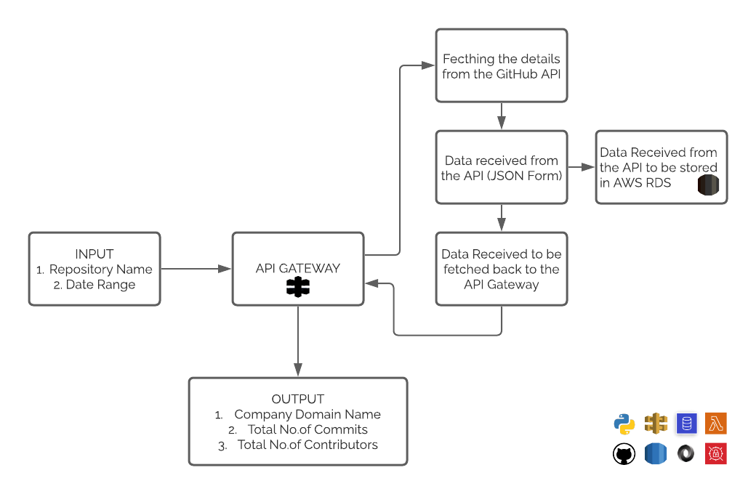

**Tech Stack**

* Python
* AWS
  + AWS API Gateway
  + AWS Secret Manager
  + AWS Lambda
  + AWS RDS
* API
  + GitHub API

Link - <https://github.com/Hanesh-Jogani/GitHub-Contributor-Aggregator>